App in a Day
Hands-on Lab Step-by-Step

Contents
Complete Solution 1
Task 1: Create a new environment 1
Task 2: Import the solution 3

Complete Solution
Follow the steps below to see the complete solution without completing the modules

Task 1: Create a new environment
- Open a new browser tab, navigate to Power Apps admin portal select Environments and click New Environment.
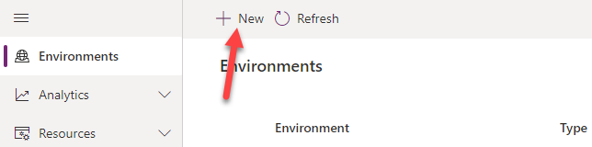
- Provide an Environment Name, select Trial for Type, select Region, select Yes, for Create a database, and click Next.
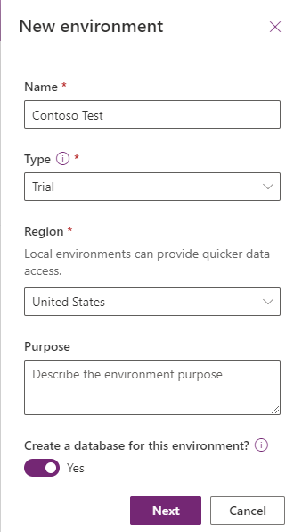
- Select Language, URL, and Currency. Choose Yes for Deploy sample apps and data and then click Save.
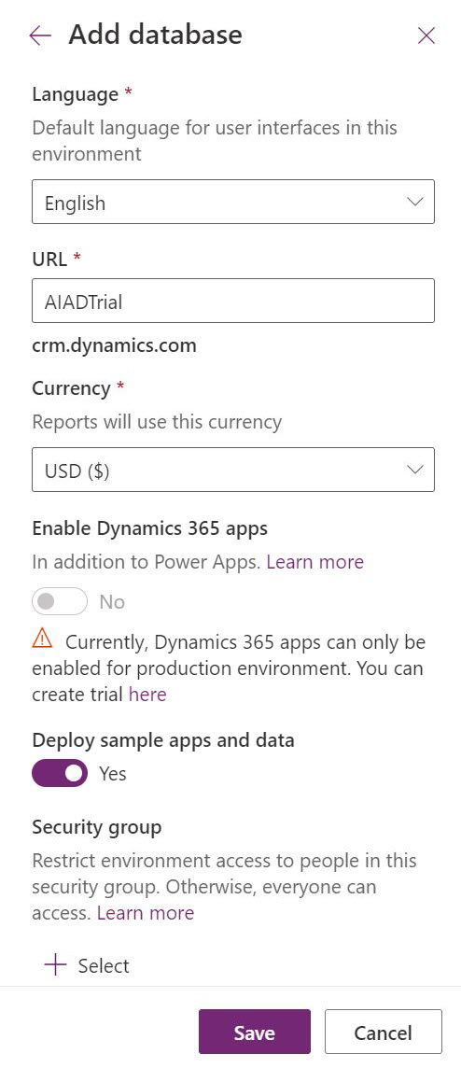
- Wait for the environment to be created.

Task 2: Import the solution
In this task, you will import the completed module 4 solution.
- Navigate to Power Apps maker portal
- Make sure you are in the Contoso Test Environment you created.
- Select Solutions.
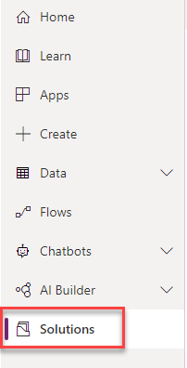
- Click Import solution.
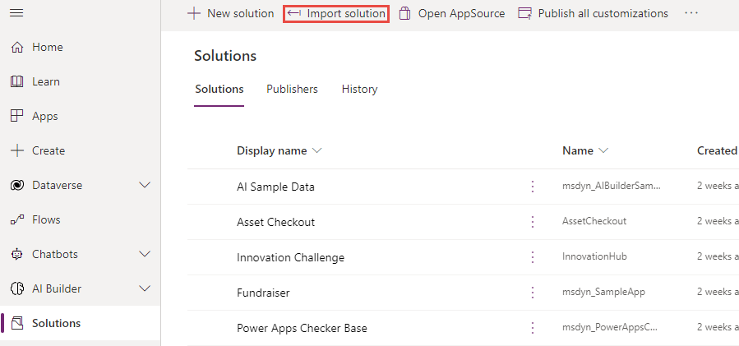
- Click Browse.
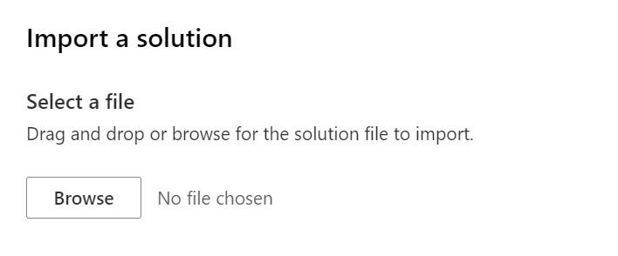
- Select the Contoso Coffee solution zip file located in Module 4 Completed folder and click Open.
- Click Next.
- Click Next again.
- Click on the connection dropdown for the Microsoft Teams connector and select + New connection.
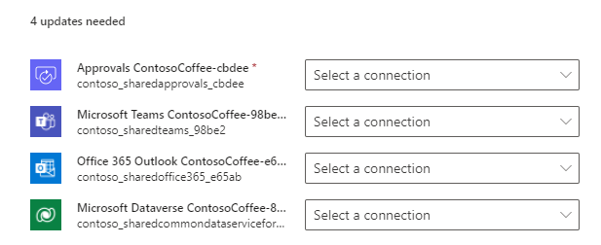
- Click Create.
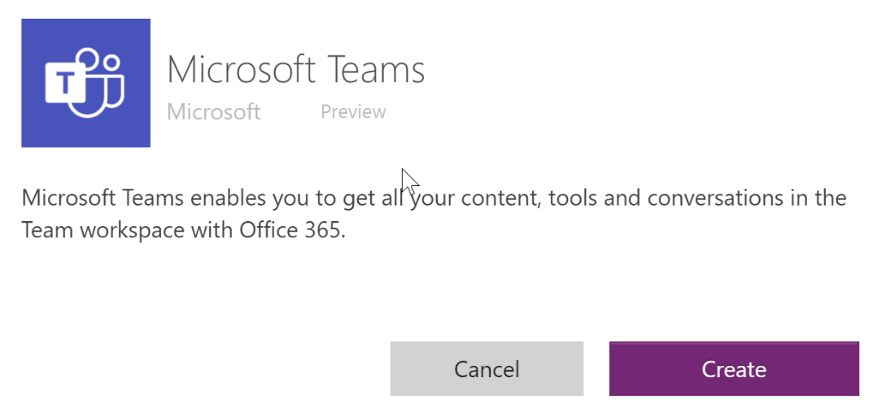
- Select your credentials.
- You should now have one connection listed. Close the connections browser tab or window.
- Click Refresh.
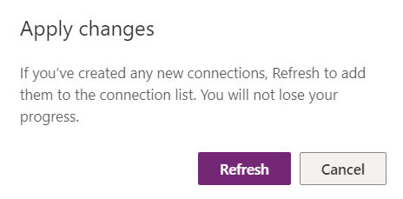
- The connection you added should get selected. Follow the same steps to add the rest of the connection.
- Add the connections and click Import.
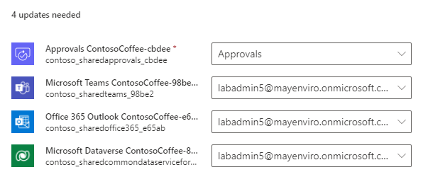
- Wait for the solution import to complete.
- Once the import is complete, Click Publish All Customizations and wait for the publishing to complete.
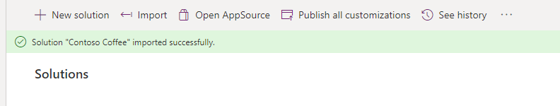
- Select Apps and launch the Machine Ordering App.
- Click Allow.
- Select few machines and click Compare.
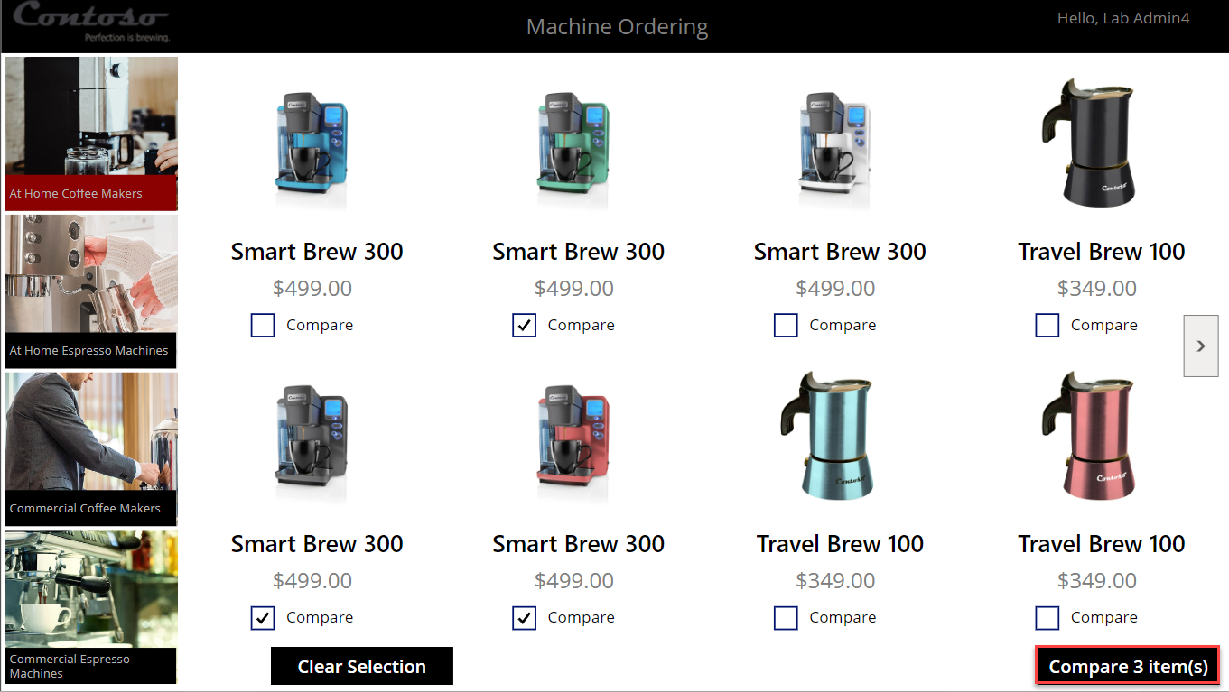
- Select one of the machines and click Submit.
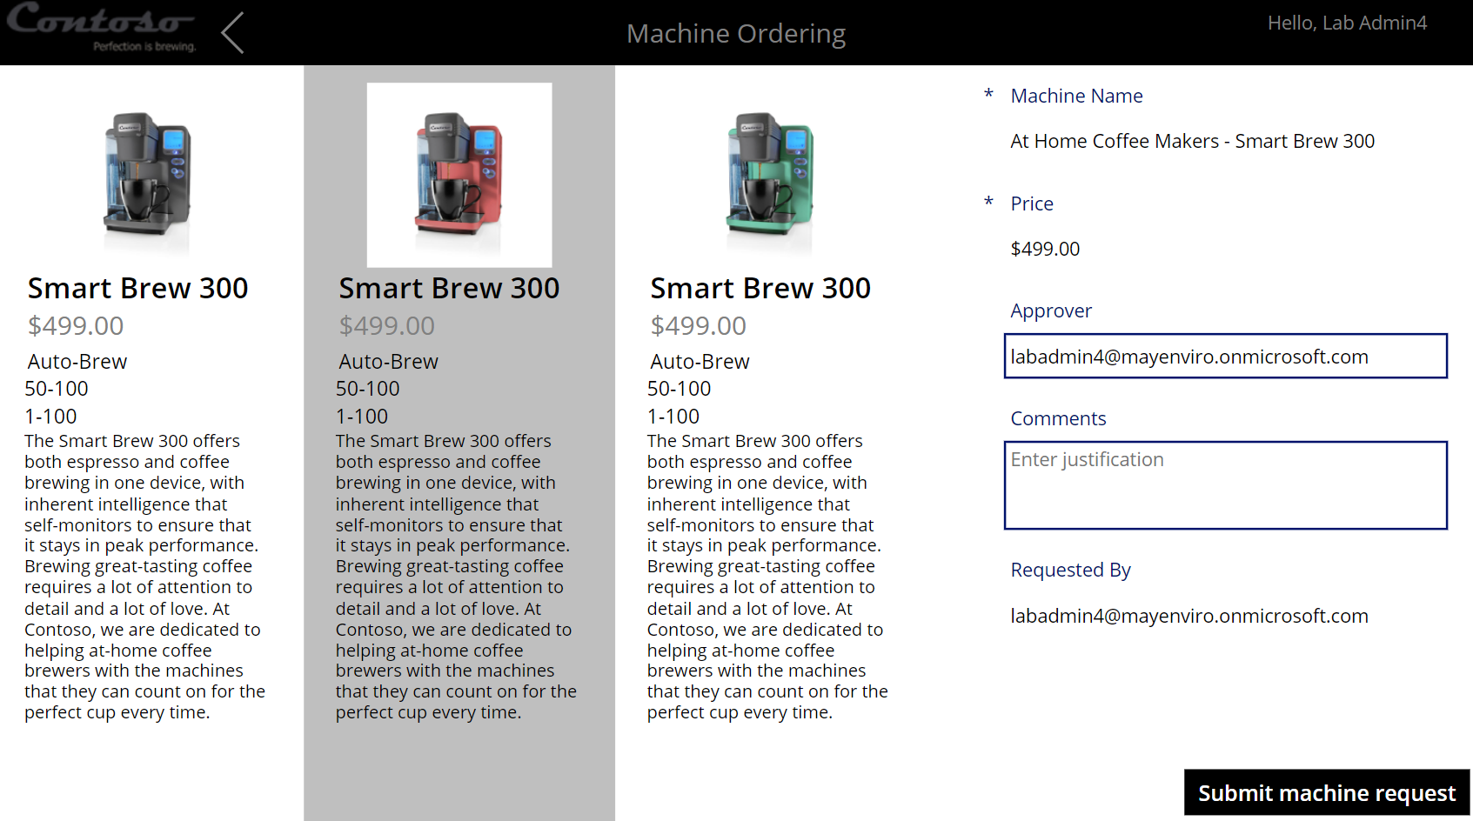
- Click OK.
- Close the application by simply closing the browser tab.
- Select Apps and launch the Machine Procurement application.
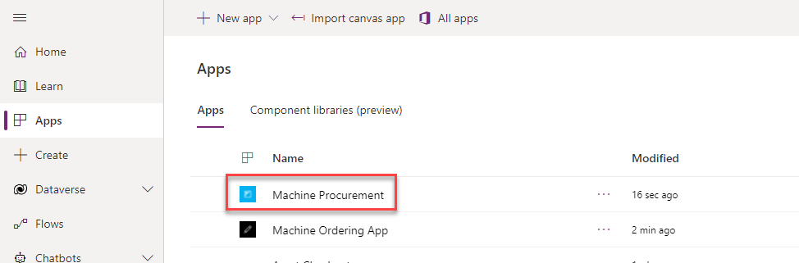
- Click to open the record you created in the last task.
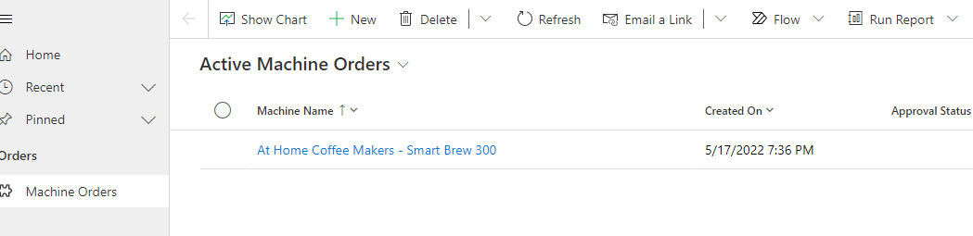
- The record should open, and you should see a business process flow.
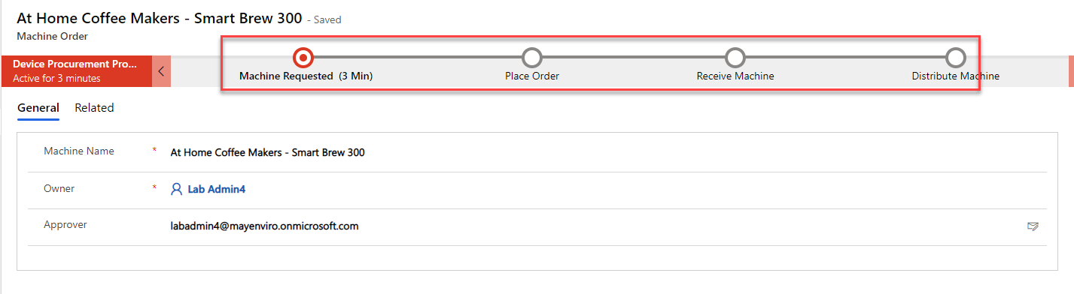
- Close the Model-driven application browser window or tab.
- Select Solutions and open the solution you imported.
- Select Cloud flows and you should see New machine approval request flow.
